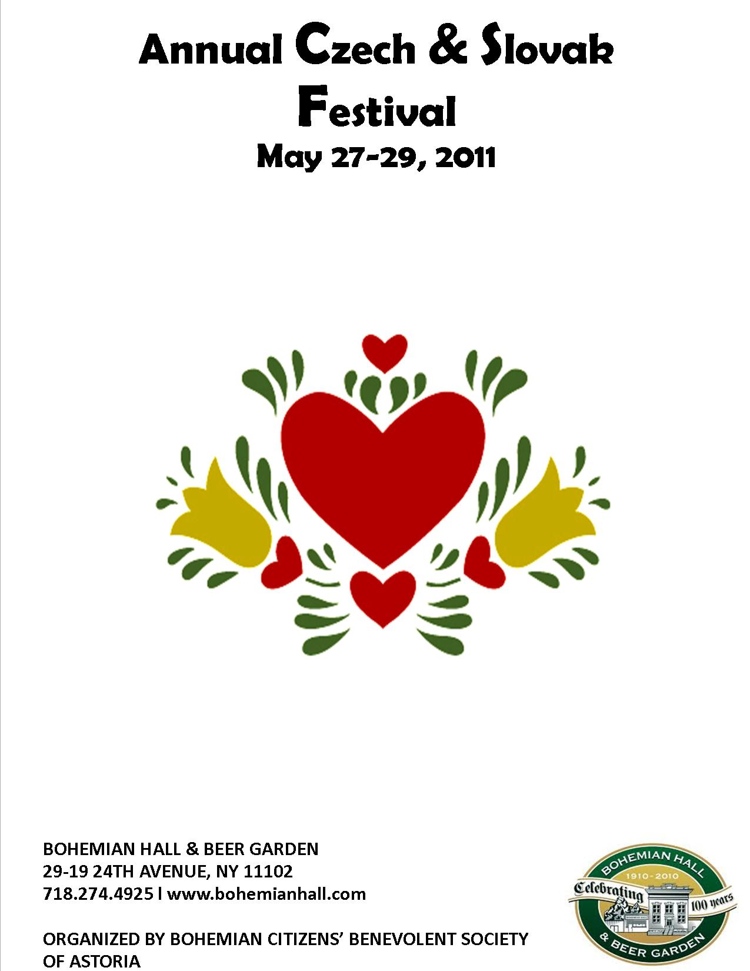
CZECH AND SLOVAK FESTIVAL MENU

Pilsner Goulash with Dumplings $14
Plzenský Guláš s Knedlíkem
Moravian Stew with Dumplings $14
Moravský Vrabec s Knedlíkem
Chicken or Pork Schnitzel with Potato Salad $14
Kuřecí nebo Vepřový Řízek s Bramborovým Šalátem
Mushroom & Potato Perogies $12
Houbové a Bramborové Pirohy
Mushroom Sauce and Dumplings $10
Knedlíky s Houbovou Omáčkou
Homemade Potato Pancakes with Apple Sauce & Sour Cream $11
Domácí Bramboráčky s Jablečným Pyré a Kysanou Smetanou

BOHEMKA GRILL MENU
Grilled Country Klobasa $10
Grilled Mushroom Burger $9
Grilled Bratwurst $10
Grilled Turkey Sausage $9
Hamburger $10
Cheese Burger $10
Veggie Burger $8

Sides
French Fries $4
House Made Potato Salad $4
Crunchy Pickles $4
Onion Rings $6

8
History of Bohemian Hall and Park
In the late 1800’s, as many Czech and Slovaks fled the oppression of Austria-Hungary, they made their way to America. Many such people found a home in Astoria, Queens.
In 1892, the Bohemian Citizens’ Benevolent Society was formed, named after the medieval Kingdom of Bohemia in the Holy Roman Empire.
Eighteen years later, in 1910, the Society began raising funds for a home for the Czech and Slovak people in our community. It was to be a haven where the traditions of the homeland would be maintained.
Two adjacent lots, part of a farm, were purchased and on October 1, 1910, the cornerstone of Bohemian Hall was laid.
Older people of the Society remember hearing stories of raising funds-at a penny a brick! Members who were masons, plumbers, and electricians volunteered their services to build Bohemian Hall. These men transformed a patch of Long Island farmland into an authentic European Beer Garden.
Bohemian Hall was actually built in three sections. What is today the entrance was the first hall, but it soon became obvious more space was needed. The Sokol gym or Main Hall was added, and in 1919 the outside Bar and Park were finished-just in time for Prohibition-which banned the sale of alcoholic beverages in America for over a decade!
But Bohemian Hall and Park survived. At one time, over 800 beer gardens were in New York City – three in Astoria alone. Only Bohemian Hall and Park survives to carry this proud tradition into the next century!

1
BCBSA PRESENTS
Theater Ungelt’s Play
“NaÚteku“

May 27th, 2011
8:00pm

A comedy starring Jana Štěpánkova &
ZlataAdamovská

Please note: The play will be performed in the Czech language.

*Donations towards BCBSA’s scholarship fund would be greatly appreciated*

2
CZECH AND SLOVAK SCHOOL
Učíme se česky a slovensky v Bohemce
We are learning Czech & Slovak at Bohemian Hall
Česká & Slovenská Škola
Chceme, aby se český a slovenský jazyk a kultura staly důležitou součástí životanašich dětí. Pro další informace o České a Slovenské škole prosím kontaktujte czskschool@bohemianhall.com
The Czech & Slovak School
Helping to assure that the Czech & Slovak language and culture remains animportant part of our children’s lives. For further information on the Czech and Slovak school please contact czskschool@bohemianhall.com
UČITELÉ/TEACHERS:
Martina Finková
Janka Hamračková
Magda Heller
Jozef Ivaška
Andrea Koch
Monika Kovalčiková
Jana Novotná
Janette Parvakis
Dana Podzuban
Jaroslav E. Sýkora
Blanka K. Sylvester (reditelka, director)

7

D.A. SOKOL GYMNASTICS
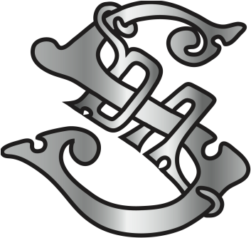

Serving the NYC Community since 1892
D.A. Sokol, Inc. Is a 501(c)3 Volunteer Gymnastics & Sports Organization
Our continued goal and motto:
“A Sound Mind in a Sound Body“
Toddler, Youth, & Adult Gymnastics

Best Wishes for a Successful Czech & Slovak Festival
NAZDAR!

D.A. Sokol holds classes for all ages in the Bohemian Hall Gymnasium
Located at 29-19 24th Avenue Astoria N.Y. 11102
BOI@DASokol.com • www.DASokol.com • (718) 545-5631

6
W-E-L-C-O-M-E
Vítame Vás

On behalf of the Bohemian Citizens’ Benevolent Society of Astoria L.I.N.Y., Inc. and our 230 volunteers and members, we welcome you to celebrate our annual Czech and Slovak Festival.
Enjoy!
Srdečne Vás všechny vítame na letošních jubilejních oslavách našeho každoročního Českého a Slovenského festivalu a to jménem našho spolku Bohemian Benevolent Society of Astoria L.I.N.Y.,Inc. a všech jeho 230členů.
Srdečne Vás všetkych výtame na tohtoročných jubilejných oslavách nášho každoročného Českého a Slovenského festivalu a to v mene nášho spolku Bohemian Citizens’ Benevolent Society of Astoria, L.I.N.Y.; Inc. a všetkých jeho230 členov.

Board of Directors: Officers:

Paul Ort Treasurer – Jana Samková
KarelŠimek Membership Secretary – Mary Seewald
MiladaŠtastný Archivist – Bill Balash
Peter Kutil (President) Editor of the Astorian – DallWilson
Alan SvobodaCzech & Slovak School Liaison – Dr. Pavel Ort
Michal Seewald
RadkaPetrova
MarosKočerha
Jana Samková

3
Saturday Program
May 28th, 2011

12:00-1:00 Doors Open
1:00-1:50 pilsner Brass Band
2:00-2:20 Opening Ceremony
-Welcome by President BCBSA
-Color Guard by DA Sokol
-National Anthems by School Children
2:40-3:00 Performance by School Children (singing)
3:00-3:15 Limboráčik
3:20-4:00 SokolExhibition
4:00-5:00 Pilsner Brass Band
5:00-5:30 JožkoBil (Contemporary Slovak Folk Artist)
5:30-5:45 Raffle
5:45 – 7:45 Pajtáši(Slovak Dulcimer Band)
7:45-10:00 Ovocničkovia (Contemporary Czech & Slovak Pop-Rock Covers

Raffle:
1st Prize One Round Trip To Prague
&Many More Impressive Prizes

4
Sunday Program
May 29th, 2011

12:00-1:00 Doors Open
1:00-2:00 Pilsner Brass Band
2:00-2:30 Opening Ceremony
-Welcome by President BCBSA
-National Anthem by JozefIvaška
2:30-3:15 Czechoslovak Moravian Club Folk Dancers from Endicott, NY
3:15-3:45 JozefIvaška
3:45-4:15 JožkoBil (Contemporary Slovak Folk Artist)
4:30-4:45 Raffle
5:00-7:00 Polka Brothers (Performing Your Favorite Polkas)
7:00-10:00 Pajtáši (Slovak Dulcimer Band)

Raffle:
1st Prize One Round Trip To Prague
&Many More Impressive and Valuable Prizes

Special Thanks to Our Sponsors:

Club 21 Koliba
Radio Slovakia USARadeburger
Staropramen Pilsner Urquell
KrušoviceTatra Travel
5

